- Given two arrays: one with actual delivery times and one with predicted delivery times for 10 Zomato orders, calculate the Mean Squared Error (MSE) and Root Mean Squared Error (RMSE) using Python.
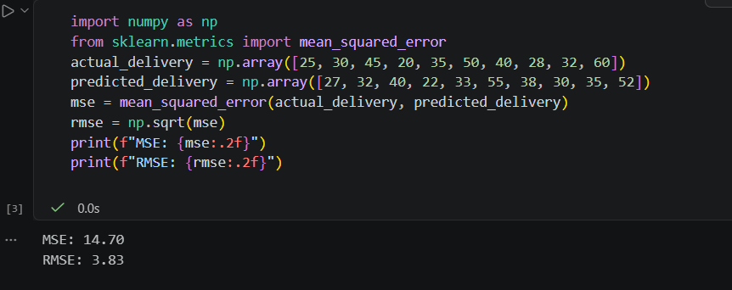

===========================================================================

- For a Flipkart product price prediction task, you have arrays of actual prices and predicted prices. Write a function to compute the Mean Absolute Error (MAE) and R² score, and print both values. Use sklearn.metrics.mean_absolute_error and sklearn.metrics.r2_score.
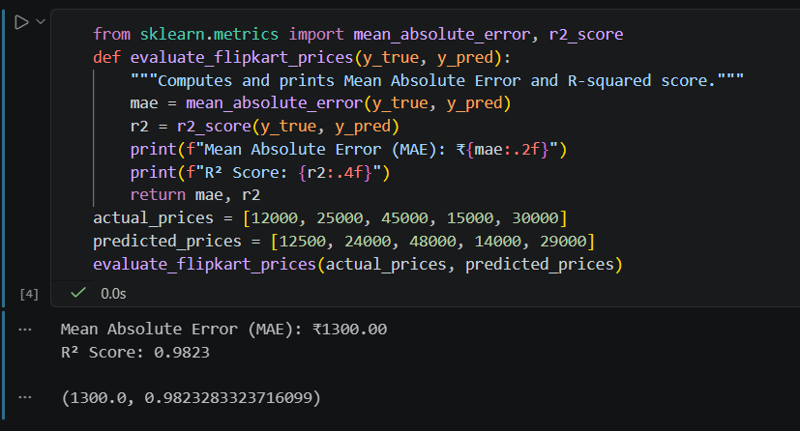
===========================================================================
- Create a residual plot for a dataset of actual vs predicted movie ratings (scale 1-5) for 20 movies, using matplotlib. Label the axes and briefly describe what the plot tells you about your model's errors.
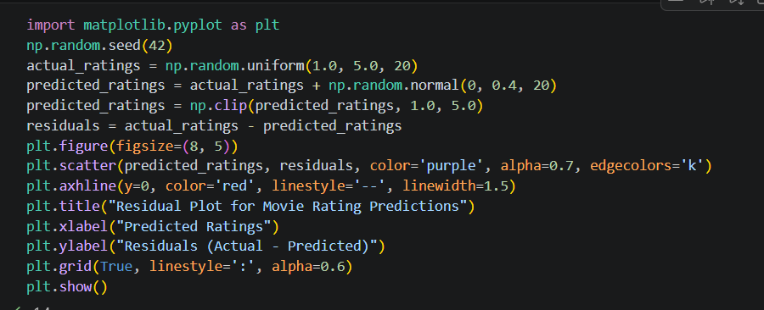

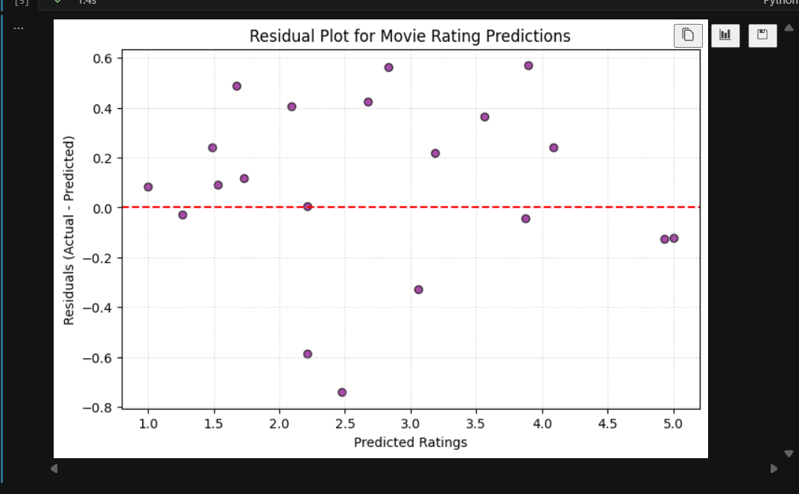

===========================================================================
- You have two models predicting the delivery time for Swiggy orders. Model A has an RMSE of 8 minutes and R² of 0.65, Model B has an RMSE of 6 minutes and R² of 0.55. Which model would you choose and why? Explain your reasoning based on the evaluation metrics.
Swiggy Model Selection (Model A vs. Model B)
- Model A: RMSE = 8 minutes, $R^{2}$ = 0.65
- Model B: RMSE = 6 minutes, $R^{2}$ = 0.55
Choice & Reasoning:
I would choose Model B. For a logistics/food delivery app like Swiggy, RMSE translates directly to operational accuracy in minutes. Model B provides tighter predictions (an average error of 6 minutes vs. 8 minutes), which is crucial for customer satisfaction and reliable ETA communication. While Model A captures slightly more overall variance ($R^{2}$ of 0.65 vs 0.55), a lower absolute error in minutes is typically prioritized in time-sensitive delivery scenarios.

===========================================================================

- Compare two regression models for predicting Spotify song popularity: calculate MSE, RMSE, MAE, and R² for both models using sklearn, then identify which model is likely overfitting based on the results. Overfitting often shows very low error on training data but much higher error on test data.

